**Project Design Phase-II**

**Technology Stack (Architecture & Stack)**

|  |  |
| --- | --- |
| Date | 04-Nov-2022 |
| Team ID | PNT2022TMID10395 |
| Project Name | Project - A Novel Handwritten Digit Recognition System |
| Maximum Marks | 4 Marks |

**Technical Architecture:**

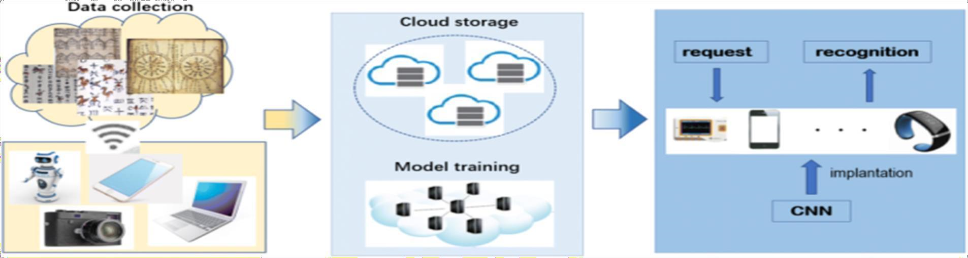

**Table-1 : Components & Technologies:**

|  |  |  |  |
| --- | --- | --- | --- |
| **S.No** | **Characteristics** | **Description** | **Technology** |
| 1. | Open-Source Frameworks | List the open-source frameworks used | Technology of Opensource framework |
| 2. | Security Implementations | List all the security / access controls implemented, use of firewalls etc. | SHA-256, Encryptions, IAM Controls,  OWASP |

|  |  |  |  |
| --- | --- | --- | --- |
| **S.No** | **Component** | **Description** | **Technology** |
| 1. | User Interface | How user interacts with application e.g. Web UI, Mobile App, Chatbot etc. | HTML, CSS, JavaScript |
| 2. | Application Logic-1 | Logic for a process in the application | Python |
| 3. | Application Logic-2 | Logic for a process in the application | IBM Watson STT service |
| 4. | Application Logic-3 | Logic for a process in the application | IBM Watson Assistant |
| 5. | Database | Data Type, Configurations etc. | MySQL, NoSQL, etc. |
| 6. | Cloud Database | Database Service on Cloud | IBM DB2, IBM Cloudant |
| 7. | File Storage | File storage requirements | IBM Block Storage |
| 8. | External API-1 | Purpose of External API used in the application | IBM Weather API |
| 9. | External API-2 | Purpose of External API used in the application | Aadhar API |
| 10. | Machine Learning Model | Purpose of Machine Learning Model | Object Recognition Model |
| 11. | Infrastructure (Server / Cloud) | Application Deployment on Local System / Cloud  Local Server Configuration  Cloud Server Configuration | Local, Cloud Foundry |

**Table-2: Application Characteristics:**

|  |  |  |  |
| --- | --- | --- | --- |
| **S.No** | **Characteristics** | **Description** | **Technology** |
| 3. | Scalable Architecture | Justify the scalability of architecture | 3 – tier, Micro-services |
| 4. | Availability | Abstract and Figures. The features for handwritten digit recognition have been introduced. These features are based on shape analysis of the digit image and extract slant or slope information. They are effective in obtaining good recognition accuracies | Distributed servers, IBM cloud |
| 5. | Performance | The standard implementations of neural networks achieve an accuracy of ~ (98–99) percent in correctly classifying the handwritten digits. | number of requests per sec, use of Cache, use of CDN’s |